Health
19/04/25
Success criteria 10
After talking to the stakeholder I decided to add a health bar in the form of multiple hearts which can be seen in games such as Zelda and Minecraft as it will be more straightforward for when I create enemies the character loses one heart per hit, which therefore will save myself time.
I created a new separate code script in a folder I named variables for when I create stamina and damage variables. Below is the code I used, the comments explain what each part does.
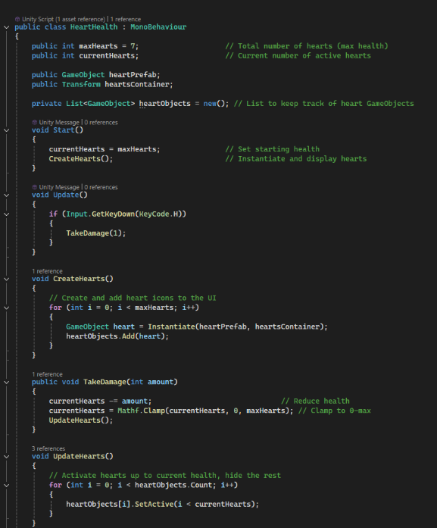

This is for when I upgrade the amount of hearts my character has in the upgrade menu in the checkpoints, it adds a heart to the heart container which is an invisible box that contains all the hearts so no more can be added than possible and gives the code a location to add the hearts into.
This is simply so I can determine whether or not the losing a heart actually works for when I add enemies.

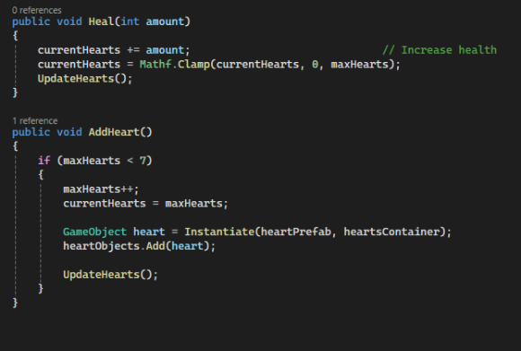
This limits the amount of hearts that can be added/ upgraded to which I have capped at 7 to not make the game too easy
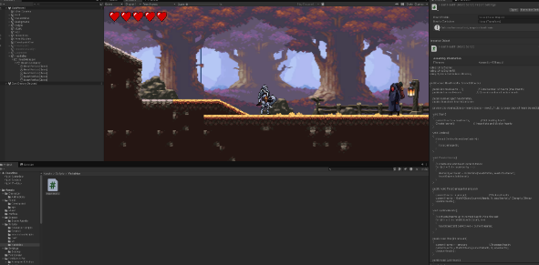
This is what the game looks like in runtime.
Item | What is expected | Does it work?
Health bar | Hearts show in the top left corner and loses a heart when H is pressed | Yes

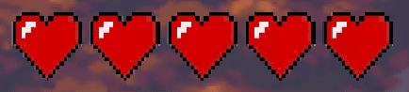

Stamina bar
29/04/25
Success criteria 11
Continuing from the success criteria, I added in a stamina bar to make the game more adaptive and strategic to play as it adds an extra layer of difficulty where you have to track how much stamina you use in order to allow yourself to still move.
To do this I created a new script aswell as setting up a new UI canvas and slider in the top left (under hearts) so the user can visualise how much stamina they are on inside unity. I’ve included comments to describe what each part does.
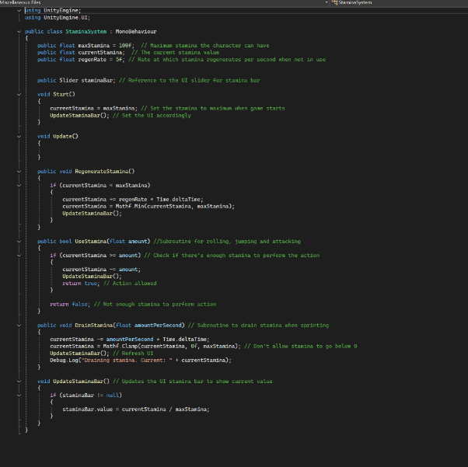
This allows stamina to regenerate over time by multiplying the regen rate by 1 second (Time.DeltaTime) meaning that it will regenerate 5 stamina every second
After this I have to reference it in the characters movement script to make these subroutines have an affect on the character.
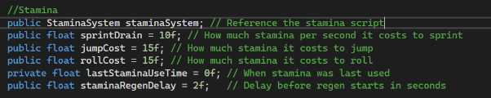
This is at the top of the script where I reference game objects and scripts and declare variables that will be used in the script.
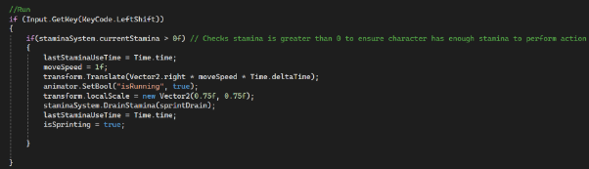
This is for when the character runs, it adds an extra if statement around the code to make the character move to check if there is enough stamina for the character to perform the action. This is the same for the jump and roll but uses a different line of code that can be seen below due to sprinting occurring while the key is held down and the jump and roll being when the key is clicked once.

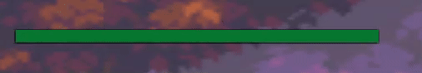

Review of the health and stamina bars
Black = Question Red = Answer
- What do you enjoy about the health and stamina bars?
I think the way they are shown on the screen is perfect, just like many other soulslikes, I think my idea of the hearts adds its own level of uniqueness so that the game will be able to be differentiated from other games. The stamina bar works well and just how I think it should be, as it doesn’t take up much of the screen and bodes well with the style of the game.
- What could I improve about the health and stamina bar?
I think the way the health and stamina bars are now perfect, and I cannot see a way to improve them.
I am happy with how the stakeholder likes the health and stamina bars, I also don’t see a way to improve them, so I think this is a well done milestone.

Interactions

NPC
18/03/2025
Success criteria 6
After deciding to add in the NPC, I wanted him to talk to the character and explain to the user what they must do in the game. I think this is a good addition and it will help add a small amount of story/ lore to my game.
In order to create the script, there was extra parts I had to learn, such as how to implement UI into the base game and reference the UI text within the code.
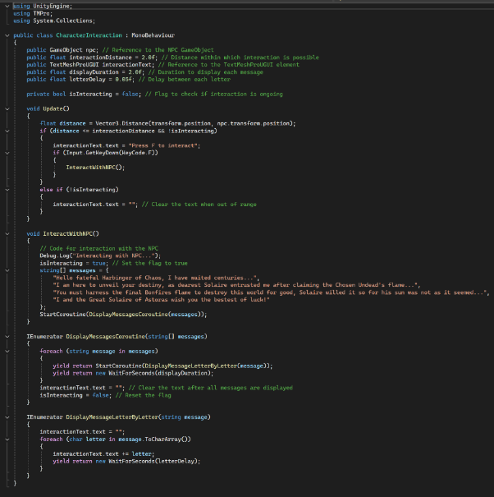
Detects the characters distance from the NPC and displays the message press F to interact if in range
Array of text that the NPC says/ shows up on the bottom of the screen, each comma is a new line that will type out after the old line
Makes the text show up letter by letter to add more retro pixel style to the game
This displays the message from the array and makes the message disappear after time

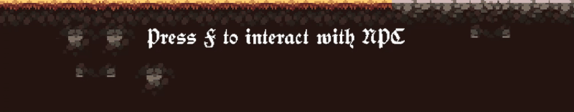

Checkpoint(s)
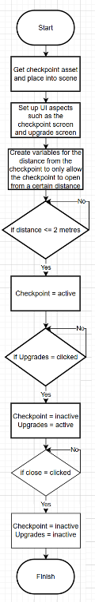
I will follow this flowchart through changing my pseudocode to actual code and making any necessary changes.

26/03/2025
Success criteria 7, 8
To create working checkpoints that utilise UI and character Upgrades I decided to use the same script as the one for the Npc to create the idea of having one single script to handle all interactions that the character will do, this makes the code more organised and prevents me having to have loads of smaller scripts that I may need to call one script inside of another (which I don’t know how to do) later in the creation. So this way it will make it much simpler and less tedious later on. (Utilising the computational thinking method: Thinking ahead)
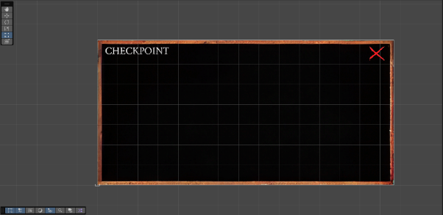
First I created a simple checkpoint screen, I will later add to this. The cross in the top corner is a button that will send you back to the main game.
Declaring the gameobject of my checkpoint.
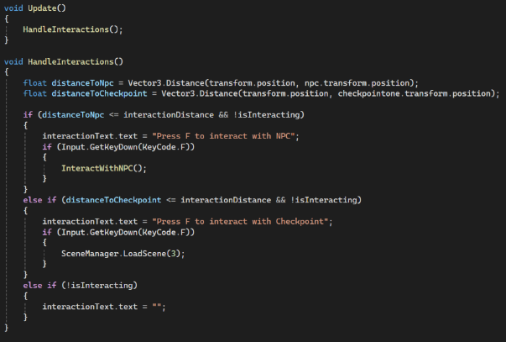
I had to add the HandleInteractions subroutine as when I previously wrote out the code it would get confused with distances and what gameobject it was accessing so it would only work for the checkpoint and not the npc. The handle interaction subroutine allows the code to understand what gameobject I am attempting to access at certain points.
Item | What is expected to happen? | Does it work?
Npc Interaction | Says press f to interact with NPC and when I do it writes out the sentences seen in the NPC part. | Yes
Checkpoint One Interaction | Says press f to interact with Checkpoint one and when I do it sends me to the checkpoint scene | Yes

After this I added the checkpoint UI, it took me quite a while to decide whether to have the UI on a separate scene, or simply add it into the main scene however, this comes with many difficulties and can cause a lot of crowding on the Unity game manager scene which can be annoying to work around. However, taking this all in I think it still is easier to add it into the main scene as with multiple scenes it can become tedious referencing them multiple times and I would have to reference separate scripts into others which I am not experienced in so overall in order to save time I chose to put it onto the main scene.

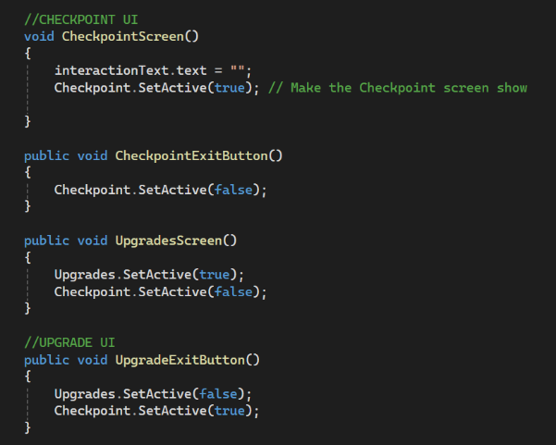
I added this simple code to the interaction script containing the open the checkpoint screen, exit the checkpoint screen, open the upgrades screen through the checkpoint screen and exit the upgrades to go back to the checkpoint one. This is useful as it means I can alter different parts of the code and upgrades to suit me, for example adding a health increase on the upgrades screen at a later date.
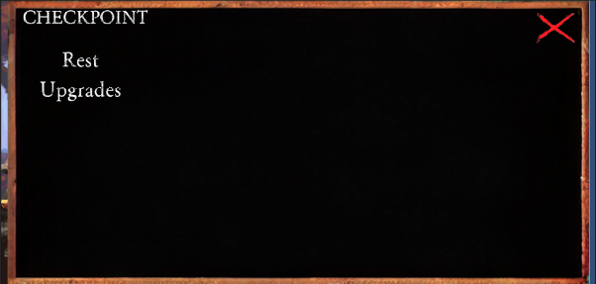
This is the checkpoint screen. I will add in when the rest button is clicked it will restore all health and flasks.
Success criteria 12
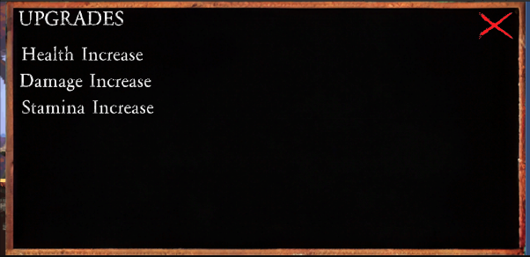
This is the upgrades screen which I can access after pressing Upgrades.
The X is used to exit the screen you are on which can be seen in the code above.

Health Increase
28/04/25
Adding a health upgrade is not that difficult as I have already added the necessary requirements in the health script in order to simply add a heart when clicked. I had to add few lines of code that can be seen below as well as reference the health script at the top of the checkpoint script as well as reference it in Unity so it knows what script to go into.
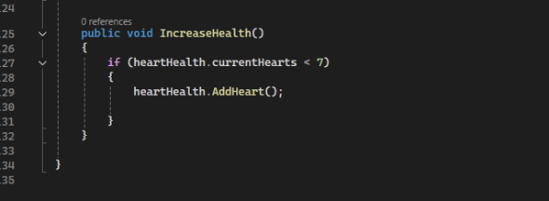

Stamina Increase
1/05/25
Adding in a Stamina upgrade is generally the same as the health bar as I want to increase the strategy and decision making of the game to make the player choose between certain upgrades.
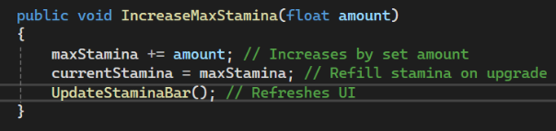
I added this into the stamina script to allow me to reference it in the interaction/ checkpoint script and upgrade the stamina by a certain amount.
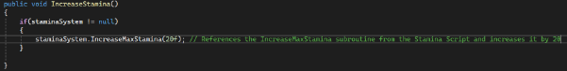
Added this to the interaction script to increase the stamina by 20.
This is all works well, however I want the player to be able to visualise this increase and you cannot see it in the slider as it doesn’t increase in length with the upgrade, to do this I had to alter parts of the stamina script to do this. 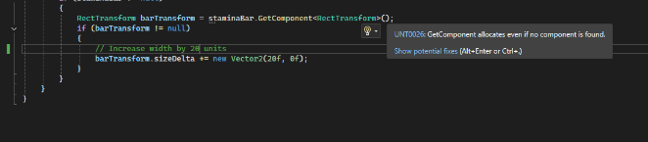
This increases the slider length by 20 which I can alter and reference in the upgrade part of the script. However, this caused the stamina bar to increase to the left, which would go off the screen so the user could not see the bar decreasing once it leaves the screen. To fix this I simply had to change the X-axis pivot anchor to zero so it cannot increase in the left, only the right.

Multiple checkpoints
2/05/25 - 11/05/25
After finishing off the stamina parts, I quickly realised that I would have to have multiple checkpoints, and this would not currently work with the code I had used.

Item | What is expected? | Does it work?
First checkpoint | Shows press f and when clicked the checkpoint screen appears | Yes
Second checkpoint | Shows press f and when clicked the checkpoint screen appears | No

I spent extremely long trying to come up with a solution for this as it deemed quite a difficult task to accomplish, however a lot of the time was spent with me searching the internet for solutions (AI: ChatGPT and Copilot, How to implement checkpoints - Unity Engine - Unity Discussions, 2d - In unity how can I make a checkpoint system - Game Development Stack Exchange, Unity-CheckPoints/README.md at master · santiandrade/Unity-CheckPoints · GitHub) and piecing together many different parts of code for it to work. I first started off by changing the reference to the checkpoint game object into an array so inside of unity I could allocate multiple checkpoints to a single variable which I could put into the code so all the checkpoints will do exactly the same thing. I then had to change the checkpoint subroutine in handle interactions from an if to a foreach statement (foreach runs through each item in the array till it matches what is specified) to work out what checkpoint was the character close to and check the isInteracting flag is not currently in use, set it to true when f is pressed and reset it after I close the tab. I had to repeatedly use the debug log to verify this was working as for a long time Unity was struggling to call the code correctly as I intended it to.
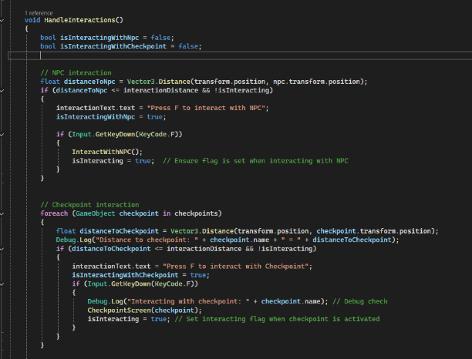

This is the code I added which I explained above
Item | What is expected to happen? | Does is work?
Npc interaction | Says ‘press f to interact’ and when f is clicked the npc speaks to you | Yes
First checkpoint | Says ‘press f to interact’ and when f is clicked the checkpoint opens | Yes
Second checkpoint | Does the same as first checkpoint however it does actually allow the interaction and the isInteracting flag resets correctly | Yes

Review of the interactions
Black = Question Red = Answer
- What do you enjoy about the interactions?
I like all the aspects of the interactions, I think they all work and are good for the game, giving me more options to change how I play and gives the game a more interactive experience. The NPC provides a greater feeling of the world being alive, and the dialogue he says is motivating.
- What could be improved about the interactions?
To improve the interactions, I think that the text from the NPC is too large and it means that it makes the words more difficult to read in succession.
After reviewing the stakeholder feedback, I think it is a good idea to make the text smaller as I can see how it would make the text difficult to read. In order to do this I can simply change the size of the textmeshpro (text) object in the inspector to be smaller, this makes the games ease of play better.

Enemies

Bat
24/07/25
The first enemy I will be adding is a bat, this will be in the first level and will be an easy enemy that will be killed with little problems and be a good introduction to the game.
I started by importing the bat asset and creating all the animations by using sprite pages that were provided.
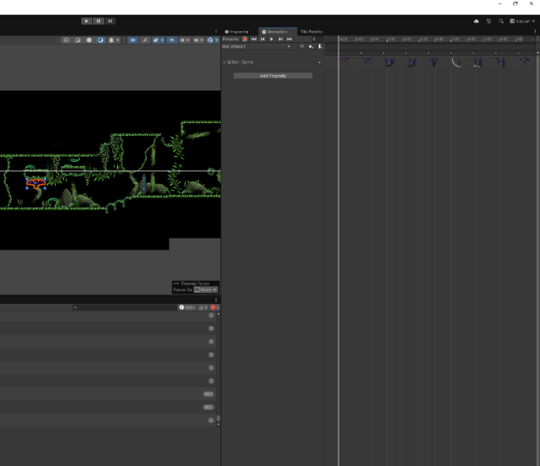
I then linked them all together in the animator and after I have made a basic script I will create parameters so they all work together.

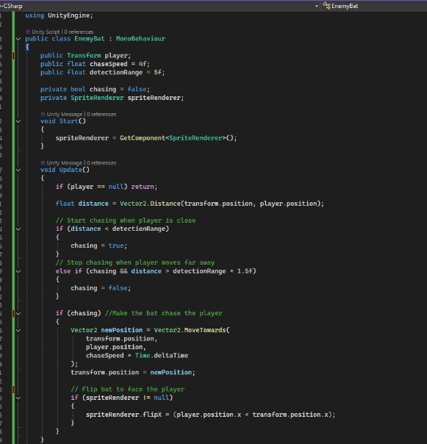
After creating the script, several errors occurred with the bat such as it becoming alerted to me way too early and the bat does not sit a certain distance away from me it just overlaps directly with the player.
I solved this by creating a stopping distance that the bat follows so it cannot overlap with me unless I intend it to do so. 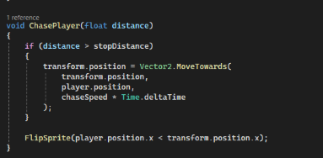
I then made the bat patrol a certain distance from where it starts to make the game feel more alive.
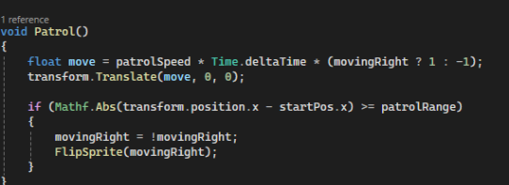
Next was making the animations work and making the bat attack the character. There was no real problems with implementing the animations as I simply made some parameters such as ‘isAttacking’ and put them into the code where necessary, referencing the animator before each line. There was various problems with getting the bat to actually damage the character though as before in the game I had multiple places referencing my health script which would in turn multiply the amount of hearts the character had in layers and would not remove some of them. Therefore I had to do multiple tests and use the inspector to determine which health script reference point I should actually use and had to replace each place where necessary, for example the characters. Then after solving this problem I simply referenced the subroutine that is in my health script to remove one of the players hearts after each hit in the bat script.
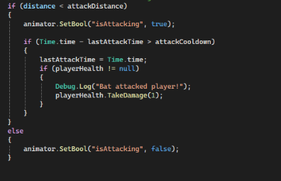
As seen if the bat is in the attacking distance the bat will play the attack animation and damage the player if the cooldown is not active.

Review of the enemies
Black = Question Red = Answer
- What do you enjoy about the enemy(s)?
I think that the current bat enemy is a good start to the games enemies and shows good promise for the others to come. The way the bat wakes up when in proximity to the character is very nice and makes the game feel more immersive like the bat actually knows we are there promoting the feel of the games world being alive.
- What could be improved about the enemy(s)?
I think that the bat could have smoother animations, as the bat sometimes jerks between the animations making the interaction feel less real.
After reviewing the stakeholder feedback, I agree with the stakeholder on the bat’s animations. In order to make the animations smoother I can simply change the exit times of the switches in animation to 0, just like I did with the character’s movement.

Reflection
I think the development went well, the stakeholder feedback was useful throughout and it provided me with good ways to make my game better. The feedback also showed that I was producing my game exactly how I wanted it to be, and that my game has good potential to be what I think is a great soulslike game. I moved through the milestones correctly and efficiently, allowing me to get most of the hardest parts of my development out of the way, so if I was to continue on with the game I would have a lighter time with the rest of the project compared to some of the more difficult and awkward parts of the project I have done.

Evaluation

Testing

Testing of entire game/ success criteria

No. | Testing | Input | Expected outcome | Actual outcome
1. | Click each button, click around the screen and press keyboard to see if anything will happen (Destructive/ stress testing) | Left-click on mouse | All buttons do their designated jobs (Start game, Exit game) | Works as expected
2. | Click the button and music should turn on/ off. Press keys/ other inputs to see if anything will happen. (Destructive/ stress testing) | Left-click on mouse | Music plays and when button is clicked once it will turn off, when clicked again it will turn back on. | Works as expected
3. | Loading screen appears for an amount of time and then game plays. | N/A | Loading screen appears for an amount of time and then game plays. | Works as expected
4. | Levels are present in the game for the character to traverse. Find areas where character could fall through map/ get stuck. | N/A | Levels are present in the game for the character to traverse. | First two levels work as expected, Last two N/A
5. | Test each key input to ensure it works. Mash keys to try and break the movement (Destructive/ stress testing). Click the screen to see if anything happens. | Q, E, A, D, Z, C, Shift and Ctrl keys | All movement works correctly | Works as expected
6. | Press interact key when inside and outside of range to ensure detection and interaction works. | F key | Prompt to interact within certain distance. NPC talks to you | Works as expected
7. | Press interact key when inside and outside of range to ensure detection and interaction works. | F key | Prompt to interact within certain distance. | Works as expected
8. | Ensure each screen opens when clicked. Click around the screen and press keys to see if anything else happens. | F key | Checkpoint screen opens and allows you to navigate around the checkpoint UI | Works as expected
9. | Ensure enemies detect you and then attack | N/A | Enemies detect you and then attack | Bat works correctly. Bosses and other enemies N/A
10. | Health bar is present and when attacked a health is lost. | N/A | Health bar is present and when attacked a health is lost. | Works as expected
11. | Stamina bar is present and when character moves stamina is lost, then regained over time | N/A | Stamina bar is present and when character moves stamina is lost, then regained over time | Works as expected
12. | Screens are present for each. Ensure when each one is clicked they do desired functions. Click around the screen and press keys to see if anything happens. Destructive/ stress testing. | Left-click mouse | Screens are present for each. Each screen/ button does desired function | Health and Stamina works as expected. Attack is N/A
13. | Item bar is present on the screen. Mash keyboard to see if it will break/ if anything happens (Destructive/ stress testing). | Numbers on keyboard | Item bar is present on screen and items can be used when numbered keys are pressed | N/A
14. | Flames are present on the screen. Flames are lost once character is upgraded. | N/A | Flames are present on the screen. Flames are lost once character is upgraded. | N/A
15. | Enemies have multiple attacks and will rotate through them. | N/A | Enemies have multiple attacks and will rotate through them. | N/A
16. | When character rolls they are invincible to damage. | Z, C keys | When character rolls they are invincible to damage. | N/A
17. | When a certain key (Not decided) clicked it will regain certain amount of health. Click multiple keys to see if anything happens. (Destructive/ stress testing) | (Not decided) key | When a certain key (Not decided) clicked it will regain certain amount of health. | N/A
18. | Flask count present on screen with icon. | N/A | Flask count present on screen with icon. | N/A
19. | Flask count resets after resting at a checkpoint or respawning | N/A | Flask count resets after resting at a checkpoint or respawning | N/A
20. | Item present in game and when used it will upgrade flask amount. Press different keys on the item to see if anything happens. | Numbers on keyboard | Item present in game and when used it will upgrade flask amount | N/A
21. | When user dies a death screen appears. | N/A | When user dies a death screen appears. | N/A
22. | User respawns at the last visited checkpoint | N/A | User respawns at the last visited checkpoint | N/A
23. | Bosses are larger than enemies | N/A | Bosses are larger than enemies | N/A
24. | Boss health bar shows at the bottom of the screen and decreases when attacked after entering arena | N/A | Boss health bar shows at the bottom of the screen and decreases when attacked after entering arena | N/A
25. | When the user moves the screen follows with the character. | N/A | When the user moves the screen follows with the character. | Works as expected
26. | Different bosses add different status effects to the character when attacked. | N/A | Different bosses add different status effects to the character when attacked. | N/A
27. | Items that are used to nullify status effects are present. Press different keys on the item to see if anything happens. | Numbers on keyboard | Items that are used to nullify status effects are present. | N/A
28. | Different music for each level is present. | N/A | Different music for each level is present. | Works as expected
29. | Cutscenes activate when bosses are killed | N/A | Cutscenes activate when bosses are killed | N/A

Evidence of testing
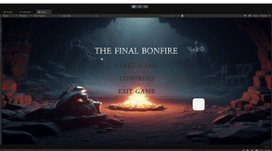
This shows how I tested the Main UI to ensure it works correctly, you can see me clicking around the screen to show that no buttons are hidden or anything will happen. I am also clicking lots of keys to show that nothing will happen and my game works as expected. The loading screen works correctly and there are no buttons on the screen. The loading screen wheel also works as expected. However, certain parts of the UI get stuck as you can see with the Control highlight got stuck as highlighted, to fix this I would have to minimize the pointer exit time for when the pointer leaves the box of the controls. Certain parts of the background images in the UI are different to the other screens, to fix this I would just scale the smaller images to be full screen size.
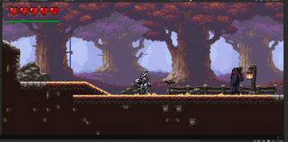
This shows how I tested the general gameplay to make sure it works as expected. You can see me run through each of the characters moves and then mash the keyboard to see if anything erratic happens – it did not. The stamina also went down when I was moving so it also works correctly. I then talked to the NPC to make sure his dialogue also worked as expected.
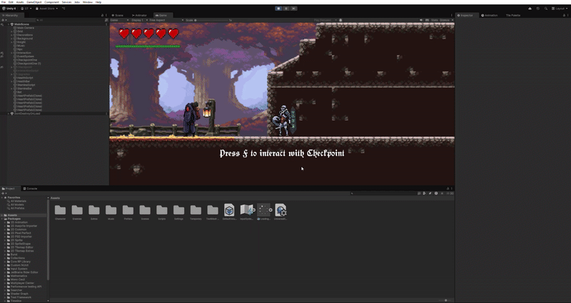
This shows how I tested more of the general gameplay as well as the checkpoint UI. I ensured that the upgrades worked as expected with health and stamina increasing when clicked. The bat also targeted me correctly and attacked me which took one of my hearts.
All of the tests I have performed have proven that my game is robust and doesn’t behave unpredictably/ erratically.

Usability features

Breaking down features

Main Menu
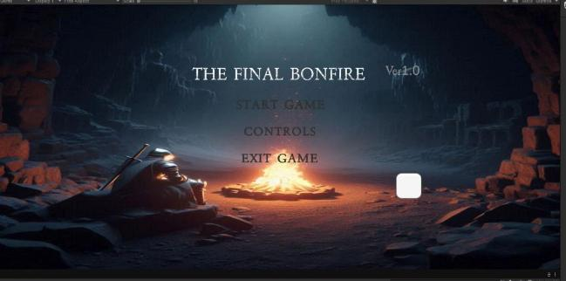
Sound button (speaker icon is on when music is off) this adds more usability and is a good addition to have for people that don’t want to hear the music.
Exit game button is located at the bottom as I want people to stay playing my game. It will be he last item users will look at on the screen
Controls button is located underneath start game as it is important the user sees it to understand the controls
Start game button to send the user into the game, located at the top of the screen as this will most likely be the button first clicked/ looked at
Title of game to indicate what the user is about to play

I can test this screen through destructive testing, allowing me to ensure there is no way for the screen to crash/ break.

Controls screen
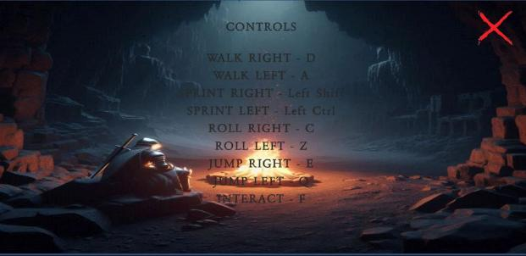
The ‘X’ button allows the user to go back to the home screen. This is needed else they would be stuck on this screen after clicking onto it
Title indicates what screen the user is on
The controls indicate what buttons the user should press to navigate through the game. It is important they understand what to do so that they can get the most out of playing the game

I can test this screen through destructive testing, allowing me to ensure there is no way for the screen to crash/ break.

Loading Screen
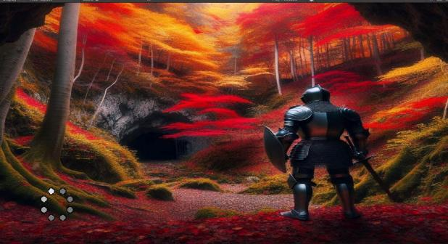
Loading wheel to indicate the game loading

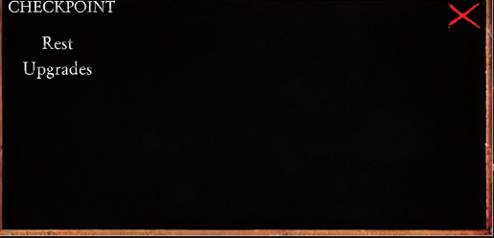
The exit button allows the user to go back to playing the game
This button will take the user to the upgrades screen. This is needed so the user can access the place to upgrade their character
Rest button to allow the character to get back to full health (and refill flasks if it was in the game)
Checkpoint title to indicate what page the user is on

I can test this screen through destructive testing, allowing me to ensure there is no way for the screen to crash/ break.

Upgrade Screen
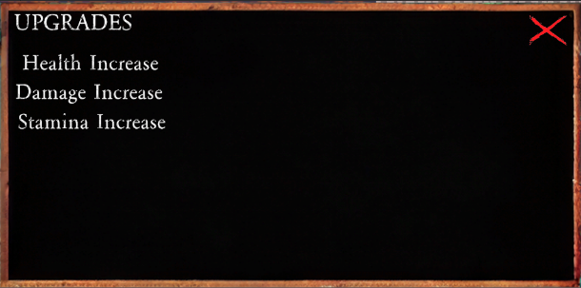
Exit button is vital for the player to be able to exit the screen and continue with the game.
These upgrades are very important for me to be able to complete success criteria point 12. It means that the user is able to upgrade their players stats so that it is easier for the player to kill enemies and promotes progression
Upgrades screen title to indicate what page the user is on

I can test this screen through destructive testing, allowing me to ensure there is no way for the screen to crash/ break.

Stakeholder testing/ review
Ed white’s review of game.
User Interface
Main menu: I like the menus music; it sets the tone for a mystical fantasy game. The ability to turn the music off is a good feature. The controls screen provides a nice, simple overview of what the controls are. The menu is overall a good, straightforward screen and anything more would start to overcomplicate things.
Checkpoints: I like the checkpoints as they look good and the UI works well and is very easy to navigate. The design choice of the checkpoints is good and fits well with the futuristic yet fantasy style, showing there is other things at work. The health and stamina upgrades work well and the cap for the health is good as to not make the game too easy.
Gameplay
Movement: The movement is smooth, there is a lot of variation and the fact you can roll, as most games don’t have that and is a unique aspect to the game. The animations flow well with each other and look good.
NPC: I like the NPC, it gives you can immersive feel into the story and provides a starting point of how to start the game. The words appearing at the bottom of the screen is good, however I think the words could have stayed on the screen for longer as I didn’t get a chance to see all the words.
Bat: The bats animations were good, and the stationary mode of rotating back and forth when the bat is not locked onto you and woken up. It is good how the bat attacks you once close enough and follows you closely.
Overall I would say that with some extra development it could turn into a very fun game and has the ability to become a great soulslike game. All the functionality and mechanics are well done and with some more levels and enemies, as well as finishing off the characters attacks this could be very good.

Stakeholder feedback analysis
After reading the feedback from the stakeholder, I think what I have created so far is exactly what I was aiming for. I believe that the feedback provides a good overview of my game and a good insight to what I have done well and what I could improve. To fix the problem of the NPC’s dialogue not staying there long enough I could simply just make the time length of the words to stay on the screen longer.

Remaining Success Criteria
SC = Success criteria

Enemies and Bosses SC 9,15,23,24,26
I only completed the first enemy (Bat) which did take a long time to do. With extra time I would follow the same process with the other enemies (Set up animations, create code, test). However, because I have already done the bat and know the process well it would take much less time or me to make the other enemies and bosses. The only difference is the bosses would have to have some extra work put in for the status effects being added in; this would be done by adding some code that would cause the player to take damage over time or having a permanent stamina reduction. The bosses would also have to have their health bars with their names located in the middle-top of the screen so the user is able to know that it’s a boss and how much health they have left. After this has been completed the extra addons in the SC would require me to enlarge the sizes of the bosses to make them visibly larger than the enemies, this would be done by increasing the scale of the bosses in the x and y axis. To add in extra attacks, I would have to repeat the process of setting up animations, creating code and then testing for each enemy. This would make the game more interesting and difficult which in turn would make the gameplay much more enjoyable.

Damage upgrade SC 12
Seeing as I have already completed the health and stamina upgrades, it would be relatively easy to add in the damage upgrade as all I have to do is update the characters overall attack damage by increasing it by a set value.

Item bar SC 13,27
To add in an item bar, given more time I would get the items first, put them around the level and then add code to them to do the desired function I want them to do. After, I would add get the item bar asset and implement it into the game, complete adding in code and run some destructive and general tests to confirm it works. This process can be repeated for adding in the extra items to nullify boss status effects.

Flames SC 14
To add flames I have to first put in a canvas, then overlay the game screen with it and put in the flames icon with a changeable number underneath. Then add some code so that the flames will increase after an enemy is killed and extra flames are added for killing a boss. Then I will have to alter the health, stamina and damage upgrades to be dependent on if the flames value is high enough to upgrade the variable they are attempting to upgrade; the price of the upgrade will then be deducted from the total value of the flames.

Rolling invincibility SC 16
Adding roll invincibility would be relatively quick to add, I would simply just have to add in some code to dictate that when the character is rolling or while the roll animation is running the characters’ health does not get affected. This could be done by either increasing the character’s health a lot while the roll is happening to create the illusion that the character doesn’t take any damage, when the roll is done the health would be returned to what it was.

Health flasks SC 17,18,19,20
To add health flasks, I would have to edit the health script to create a function that would allow me to increase the health of the character when I press a key (most likely H). I would then add an icon for the health flask on the canvas that the flames also feature on with a variable number underneath the flask icon. This would indicate how many flasks the user has, when the player uses one, it will decrease the number of flasks by one. After, I would alter the checkpoint script so that when the player presses the ‘Rest’ button it will reset the number of flasks to full. Finally, I would implement a new item that would increase the amount of flasks the player can hold at a time. This would be done through adding the upgrade asset and placing it around the levels, then I would create a subroutine that would link to the asset and make it increase the number of flasks held by 1.

Death process SC 21,22
When the character dies, a death screen needs to play out. I would do this by simply adding a new scene in, placing the words YOU DIED! In the middle of the screen and make it play for a certain amount of time. I would then add some code to the checkpoints so that when you respawn it will go to the most recently visited checkpoint. I believe that this will take quite a long time as I don’t currently know how to do that and will have to have more time to research it.

Cutscenes SC 29
This will be relatively easy to do, as all I actually have to do is add in code to the boss scripts so that for example if health <= 0 { run (bossName)cutscene }.

Overall review of the project
I think overall I did well in the project in terms of efficiency of work and code quality. I could have managed my time better and granted more, I would be able to manage it a lot better and continue to finish the game. I think that the game itself was good and looks and feels like just what I was aiming for in terms of a dark fantasy, soulslike world and gameplay. There were various limitations in the making of my game, specifically time and having to manage between other a level work I had to do. I think some of the code I had written to begin with and some of the ways I had taken on certain problems could’ve been dealt with better so that I didn’t have to waste a lot of time doing them, which could’ve given me more time to work on other parts of the project. If I did it again, I would be a lot more open minded to how I approach each problem and focus on the important parts of getting it right. I think the stakeholder feedback was good, and I agree completely with everything said. I would take into consideration changing the length of the NPCs speech and also finishing the characters attacks as I currently have not done that and it would make the game more like what I’m attempting to do. So therefore, with more time I am sure I would be able to turn this game into everything I have planned and much more.

Code Overview
This is all the code that was included in my game.

Character

Movement
using UnityEngine;
using System.Collections;
using Unity.VisualScripting;

public class Movement : MonoBehaviour
{
//general
private SpriteRenderer SpriteRenderer;
public Animator animator;
SpriteRenderer sprite;
private Rigidbody2D rb;

//Run,Walk
float dirX, moveSpeed = 0f;
bool isSprinting = false; // When true stamina will decrease

//Jump
public float jumpForce = 10f;
public float jumpAngle = 45f;
public float jumpCooldown = 1.5f;
public float nextJumpTime = 0f;

//Roll
public float rollSpeed = 5f;
public float rollCooldown = 1.5f;
private float nextRollTime = 0f;

//Stamina
public StaminaSystem staminaSystem; // Reference the stamina script
public float sprintDrain = 10f; // How much stamina per second it costs to sprint
public float jumpCost = 15f; // How much stamina it costs to jump
public float rollCost = 15f; // How much stamina it costs to roll
private float lastStaminaUseTime = 0f; // When stamina was last used
public float staminaRegenDelay = 2f; // Delay before regen starts in seconds

// Start is called once before the first execution of Update after the MonoBehaviour is created
void Start()
{
SpriteRenderer = GetComponent<SpriteRenderer>();
rb = GetComponent<Rigidbody2D>();
rb.constraints = RigidbodyConstraints2D.FreezeRotation;

}

// Update is called once per frame
void Update()
{
isSprinting = false;

//Walk
if (Input.GetKey(KeyCode.D))
{
moveSpeed = 0.5f;
transform.Translate(Vector2.right * moveSpeed * Time.deltaTime);
animator.SetBool("isWalking", true);
transform.localScale = new Vector2(0.75f, 0.75f);

}
else if (Input.GetKey(KeyCode.A))
{
moveSpeed = 0.5f;
transform.Translate(Vector2.left * moveSpeed * Time.deltaTime);
animator.SetBool("isWalking", true);
transform.localScale = new Vector2(-0.75f, 0.75f);

}
else
{
animator.SetBool("isWalking", false);
}

//Run
if (Input.GetKey(KeyCode.LeftShift))
{
if(staminaSystem.currentStamina > 0f) // Checks stamina is greater than 0 to ensure character has enough stamina to perform action
{
lastStaminaUseTime = Time.time;
moveSpeed = 1f;
transform.Translate(Vector2.right * moveSpeed * Time.deltaTime);
animator.SetBool("isRunning", true);
transform.localScale = new Vector2(0.75f, 0.75f);
staminaSystem.DrainStamina(sprintDrain);
lastStaminaUseTime = Time.time;
isSprinting = true;

}

}
else if (Input.GetKey(KeyCode.LeftControl))
{
if(staminaSystem.currentStamina > 0f)
{
lastStaminaUseTime = Time.time;
moveSpeed = 1f;
transform.Translate(Vector2.left * moveSpeed * Time.deltaTime);
animator.SetBool("isRunning", true);
transform.localScale = new Vector2(-0.75f, 0.75f);
staminaSystem.DrainStamina(sprintDrain);
lastStaminaUseTime = Time.time;
isSprinting = true;
}
}
else
{
animator.SetBool("isRunning", false);

}

//Jump
if(Time.time >= nextJumpTime)
{
if (Input.GetKeyDown(KeyCode.E))
{
if(staminaSystem.UseStamina(jumpCost)) // Checks stamina is greater than the stamina cost to jump
{
lastStaminaUseTime = Time.time;
float angleInRadians = jumpAngle * Mathf.Deg2Rad;
Vector2 jumpDirection = new Vector2(Mathf.Cos(angleInRadians), Mathf.Sin(angleInRadians));
rb.linearVelocity = jumpDirection * jumpForce;
animator.SetTrigger("Jump");
transform.localScale = new Vector2(0.75f, 0.75f);
nextJumpTime = Time.time + jumpCooldown;
}

}
else if (Input.GetKeyDown(KeyCode.Q))
{
if(staminaSystem.UseStamina(jumpCost))
{
lastStaminaUseTime = Time.time;
float angleInRadians = jumpAngle * -Mathf.Deg2Rad;
Vector2 jumpDirection = new Vector2(Mathf.Cos(angleInRadians), Mathf.Sin(angleInRadians));
rb.linearVelocity = -jumpDirection * jumpForce;
animator.SetTrigger("Jump");
transform.localScale = new Vector2(-0.75f, 0.75f);
nextJumpTime = Time.time + jumpCooldown;
}
}
else
{
animator.SetBool("isIdle", true);
}
}

//Roll
if (Time.time >= nextRollTime)
{
if (Input.GetKeyDown(KeyCode.C))
{
if(staminaSystem.UseStamina(rollCost)) // Checks stamina is greater than the stamina cost to roll
{
lastStaminaUseTime = Time.time;
Vector2 rollDirection = transform.right;
rb.linearVelocity = rollDirection * rollSpeed;
animator.SetTrigger("Roll");
transform.localScale = new Vector2(0.75f, 0.75f);
nextRollTime = Time.time + rollCooldown;
}
}
else if (Input.GetKeyDown(KeyCode.Z))
{
if(staminaSystem.UseStamina(rollCost))
{
lastStaminaUseTime = Time.time;
Vector2 rollDirection = -transform.right;
rb.linearVelocity = rollDirection * rollSpeed;
animator.SetTrigger("Roll");
transform.localScale = new Vector2(-0.75f, 0.75f);
nextRollTime = Time.time + rollCooldown;
}
}
}

if (!isSprinting && !Input.GetKey(KeyCode.E) && !Input.GetKey(KeyCode.Q) &&
!Input.GetKeyDown(KeyCode.C) && !Input.GetKeyDown(KeyCode.Z)) // Makes the character regenerate if the user is not sprinting, jumping or rolling
{
staminaSystem.RegenerateStamina();
}
}
}

Health
using UnityEngine;
using UnityEngine.UI;
using System.Collections.Generic;

public class HeartHealth : MonoBehaviour
{
public int maxHearts = 7; // Total number of hearts (max health)
public int currentHearts; // Current number of active hearts

public GameObject heartPrefab;
public Transform heartsContainer;

private List<GameObject> heartObjects = new(); // List to keep track of heart GameObjects

void Start()
{
currentHearts = maxHearts; // Set starting health
CreateHearts(); // Instantiate and display hearts
}

void Update()
{
if (Input.GetKeyDown(KeyCode.H))
{
TakeDamage(1);
}
}

void CreateHearts()
{
// Create and add heart icons to the UI
for (int i = 0; i < maxHearts; i++)
{
GameObject heart = Instantiate(heartPrefab, heartsContainer);
heartObjects.Add(heart);
}
}

public void TakeDamage(int amount)
{
Debug.Log("player took damage" + amount);
currentHearts -= amount; // Reduce health
currentHearts = Mathf.Clamp(currentHearts, 0, maxHearts); // Clamp to 0–max
UpdateHearts();
}

void UpdateHearts()
{
// Activate hearts up to current health, hide the rest
for (int i = 0; i < heartObjects.Count; i++)
{
heartObjects[i].SetActive(i < currentHearts);
}
}

public void Heal(int amount)
{
currentHearts += amount; // Increase health
currentHearts = Mathf.Clamp(currentHearts, 0, maxHearts);
UpdateHearts();
}

public void AddHeart()
{
if (maxHearts < 7)
{
maxHearts++;
currentHearts = maxHearts;

GameObject heart = Instantiate(heartPrefab, heartsContainer);
heartObjects.Add(heart);

UpdateHearts();
}
}

}

Stamina
using UnityEngine;
using UnityEngine.UI;

public class StaminaSystem : MonoBehaviour
{
public float maxStamina = 100f; // Maximum stamina the character can have
public float currentStamina; // The current stamina value
public float regenRate = 5f; // Rate at which stamina regenerates per second when not in use

public Slider staminaBar; // Reference to the UI slider for stamina bar

void Start()
{
currentStamina = maxStamina; // Set current stamina to max when the game starts
UpdateStaminaBar(); // Update UI
}

void Update()
{

}

public void RegenerateStamina()
{
if (currentStamina < maxStamina)
{
currentStamina += regenRate * Time.deltaTime;
currentStamina = Mathf.Min(currentStamina, maxStamina);
UpdateStaminaBar();
}
}

public bool UseStamina(float amount) //Subroutine for rolling, jumping and attacking
{
if (currentStamina >= amount) // Check if there's enough stamina to perform the action
{
currentStamina -= amount;
UpdateStaminaBar();
return true; // Action allowed
}

return false; // Not enough stamina to perform action
}

public void DrainStamina(float amountPerSecond) // Subroutine to drain stamina when sprinting
{
currentStamina -= amountPerSecond * Time.deltaTime;
currentStamina = Mathf.Clamp(currentStamina, 0f, maxStamina); // Don't allow stamina to go below 0
UpdateStaminaBar(); // Refresh UI
Debug.Log("Draining stamina. Current: " + currentStamina);
}

void UpdateStaminaBar() // Updates the UI stamina bar to show current value
{
if (staminaBar != null)
{
staminaBar.value = currentStamina / maxStamina;
}
}

public void IncreaseMaxStamina(float amount)
{
maxStamina += amount; // Increases by set amount
currentStamina = maxStamina; // Refill stamina on upgrade
UpdateStaminaBar();

if (staminaBar != null)
{
RectTransform barTransform = staminaBar.GetComponent<RectTransform>();
if (barTransform != null)
{
// Increase width by 20 units
barTransform.sizeDelta += new Vector2(20f, 0f);
}
}
}
}

General

Side Scrolling Camera
using UnityEngine;

public class sideScrollingCamera : MonoBehaviour
{
public Transform player;
public float offsetX = 5f;
public float smoothSpeed = 0.125f;

// Start is called once before the first execution of Update after the MonoBehaviour is created
void Start()
{

}

// Update is called once per frame
void LateUpdate()
{
Vector3 desiredPosition = new Vector3(player.position.x + offsetX, transform.position.y, transform.position.z);
Vector3 smoothedPosition = Vector3.Lerp(transform.position, desiredPosition, smoothSpeed);
transform.position = smoothedPosition;
}
}

Interaction

Character interactions
using UnityEngine;
using TMPro;
using System.Collections;
using UnityEngine.SceneManagement;
using Unity.VisualScripting;

public class CharacterInteraction : MonoBehaviour
{
// Reference GameObjects
public GameObject npc;
public GameObject[] checkpoints;
public GameObject Checkpoint;
public GameObject Upgrades;
public HeartHealth heartHealth;
public StaminaSystem staminaSystem;

public float interactionDistance = 2.0f; // Distance within which interaction is possible
public TextMeshProUGUI interactionText; // Reference to the TextMeshProUGUI element
public float displayDuration = 2.0f; // Duration to display each message
public float letterDelay = 0.1f; // Delay between each letter

private bool isInteracting = false; // Flag to check if interaction is ongoing

void Start()
{
Checkpoint.SetActive(false);
Upgrades.SetActive(false);
}

void Update()
{
HandleInteractions();
}

void HandleInteractions()
{
bool isInteractingWithNpc = false;
bool isInteractingWithCheckpoint = false;

// NPC interaction
float distanceToNpc = Vector3.Distance(transform.position, npc.transform.position);
if (distanceToNpc <= interactionDistance && !isInteracting)
{
interactionText.text = "Press F to interact with NPC";
isInteractingWithNpc = true;

if (Input.GetKeyDown(KeyCode.F))
{
InteractWithNPC();
isInteracting = true; // Ensure flag is set when interacting with NPC
}
}

// Checkpoint interaction
foreach (GameObject checkpoint in checkpoints)
{
float distanceToCheckpoint = Vector3.Distance(transform.position, checkpoint.transform.position);
if (distanceToCheckpoint <= interactionDistance && !isInteracting)
{
interactionText.text = "Press F to interact with Checkpoint";
isInteractingWithCheckpoint = true;
if (Input.GetKeyDown(KeyCode.F))
{
CheckpointScreen(checkpoint);
isInteracting = true; // Set interacting flag when checkpoint is activated
}
}
}

// Clear the text if no interaction
if (!isInteractingWithNpc && !isInteractingWithCheckpoint && !isInteracting)
{
interactionText.text = "";
}
}

//NPC INTERACTION
void InteractWithNPC()
{
// Code for interaction with the NPC
isInteracting = true; // Set the flag to true
string[] messages = {
"Hello fateful Harbinger of Chaos, I have waited centuries...",
"I am here to unveil your destiny, as dearest Solaire entrusted me after claiming the Chosen Undead's flame...",
"You must harness the final Bonfires flame to destroy this world for good, Solaire willed it so for his sun was not as it seemed...",
"I and the Great Solaire of Astoras wish you the bestest of luck!"
};
StartCoroutine(DisplayMessagesCoroutine(messages));
}

IEnumerator DisplayMessagesCoroutine(string[] messages)
{
foreach (string message in messages)
{
yield return StartCoroutine(DisplayMessageLetterByLetter(message));
yield return new WaitForSeconds(displayDuration);
}
interactionText.text = ""; // Clear the text after all messages are displayed
isInteracting = false; // Reset the flag
}

IEnumerator DisplayMessageLetterByLetter(string message)
{
interactionText.text = "";
foreach (char letter in message.ToCharArray())
{
interactionText.text += letter;
yield return new WaitForSeconds(letterDelay);
}
}

IEnumerator ResetInteractionFlag()
{
yield return new WaitForSeconds(displayDuration);
isInteracting = false; // Reset the flag after a delay
}

//CHECKPOINT UI
void CheckpointScreen(GameObject checkpoint)
{
interactionText.text = "";
Checkpoint.SetActive(true); // Make the Checkpoint screen show
StartCoroutine(ResetInteractionFlag());

}

public void CheckpointExitButton()
{
Checkpoint.SetActive(false);
}

public void UpgradesScreen()
{
Upgrades.SetActive(true);
Checkpoint.SetActive(false);
}

//UPGRADE UI
public void UpgradeExitButton()
{
Upgrades.SetActive(false);
Checkpoint.SetActive(true);
}

public void IncreaseHealth()
{
if (heartHealth.currentHearts < 7)
{
heartHealth.AddHeart();

}
}

public void IncreaseStamina()
{
if(staminaSystem != null)
{
staminaSystem.IncreaseMaxStamina(20f); // References the IncreaseMaxStamina subroutine from the Stamina Script and increases it by 20
}

}
}

NPC
This is the code for the interaction for just the NPC ( taken from the character interactions)
public GameObject npc;

public float interactionDistance = 2.0f; // Distance within which interaction is possible
public TextMeshProUGUI interactionText; // Reference to the TextMeshProUGUI element
public float displayDuration = 2.0f; // Duration to display each message
public float letterDelay = 0.1f; // Delay between each letter
void Update()
{
HandleInteractions();
}

void HandleInteractions()
{
bool isInteractingWithNpc = false;
private bool isInteracting = false; // Flag to check if interaction is ongoing
void Update()
{
HandleInteractions();
}

void HandleInteractions()
{
bool isInteractingWithNpc = false;
bool isInteractingWithCheckpoint = false;

// NPC interaction
float distanceToNpc = Vector3.Distance(transform.position, npc.transform.position);
if (distanceToNpc <= interactionDistance && !isInteracting)
{
interactionText.text = "Press F to interact with NPC";
isInteractingWithNpc = true;

if (Input.GetKeyDown(KeyCode.F))
{
InteractWithNPC();
isInteracting = true; // Ensure flag is set when interacting with NPC
}
}
// Clear the text if no interaction
if (!isInteractingWithNpc && !isInteractingWithCheckpoint && !isInteracting)
{
interactionText.text = "";
}
//NPC INTERACTION
void InteractWithNPC()
{
// Code for interaction with the NPC
isInteracting = true; // Set the flag to true
string[] messages = {
"Hello fateful Harbinger of Chaos, I have waited centuries...",
"I am here to unveil your destiny, as dearest Solaire entrusted me after claiming the Chosen Undead's flame...",
"You must harness the final Bonfires flame to destroy this world for good, Solaire willed it so for his sun was not as it seemed...",
"I and the Great Solaire of Astoras wish you the bestest of luck!"
};
StartCoroutine(DisplayMessagesCoroutine(messages));
}

IEnumerator DisplayMessagesCoroutine(string[] messages)
{
foreach (string message in messages)
{
yield return StartCoroutine(DisplayMessageLetterByLetter(message));
yield return new WaitForSeconds(displayDuration);
}
interactionText.text = ""; // Clear the text after all messages are displayed
isInteracting = false; // Reset the flag
}

IEnumerator DisplayMessageLetterByLetter(string message)
{
interactionText.text = "";
foreach (char letter in message.ToCharArray())
{
interactionText.text += letter;
yield return new WaitForSeconds(letterDelay);
}
}

IEnumerator ResetInteractionFlag()
{
yield return new WaitForSeconds(displayDuration);
isInteracting = false; // Reset the flag after a delay
}

Checkpoint
This is the code for the interaction for just the Checkpoints (taken from the character interactions)
public GameObject[] checkpoints;
public GameObject Checkpoint;
public float interactionDistance = 2.0f; // Distance within which interaction is possible
private bool isInteracting = false; // Flag to check if interaction is ongoing
void Start()
{
Checkpoint.SetActive(false);
}
void Update()
{
HandleInteractions();
}

void HandleInteractions()
{
bool isInteractingWithCheckpoint = false;
// Checkpoint interaction
foreach (GameObject checkpoint in checkpoints)
{
float distanceToCheckpoint = Vector3.Distance(transform.position, checkpoint.transform.position);
if (distanceToCheckpoint <= interactionDistance && !isInteracting)
{
interactionText.text = "Press F to interact with Checkpoint";
isInteractingWithCheckpoint = true;
if (Input.GetKeyDown(KeyCode.F))
{
CheckpointScreen(checkpoint);
isInteracting = true; // Set interacting flag when checkpoint is activated
}
}
}

// Clear the text if no interaction
if (!isInteractingWithNpc && !isInteractingWithCheckpoint && !isInteracting)
{
interactionText.text = "";
}
}
//CHECKPOINT UI
void CheckpointScreen(GameObject checkpoint)
{
interactionText.text = "";
Checkpoint.SetActive(true); // Make the Checkpoint screen show
StartCoroutine(ResetInteractionFlag());

}

public void CheckpointExitButton()
{
Checkpoint.SetActive(false);
}

public void UpgradesScreen()
{
Upgrades.SetActive(true);
Checkpoint.SetActive(false);
}

Upgrades
This is the code for the interaction for just the Upgrades (taken from the character interactions)
//UPGRADE UI
public void UpgradeExitButton()
{
Upgrades.SetActive(false);
Checkpoint.SetActive(true);
}

public void IncreaseHealth()
{
if (heartHealth.currentHearts < 7)
{
heartHealth.AddHeart();

}
}

public void IncreaseStamina()
{
if(staminaSystem != null)
{
staminaSystem.IncreaseMaxStamina(20f); // References the IncreaseMaxStamina subroutine from the Stamina Script and increases it by 20
}

}

Tests

TextMeshPro calling test
This was used to ensure that I was calling the TMP object built into unity correctly as I was having trouble with it when making the NPC interaction for the words showing up on the bottom of the screen.
using UnityEngine;
using TMPro;

public class texttestscript : MonoBehaviour
{
public TextMeshProUGUI testText;

// Start is called once before the first execution of Update after the MonoBehaviour is created
void Start()
{
testText.text = "Hello, World!";
}

// Update is called once per frame
void Update()
{

}

UI

Loading Screen
using UnityEngine;
using UnityEngine.SceneManagement;
using System.Collections;

public class loadingScreen1 : MonoBehaviour
{
public Animator animator;

// Start is called once before the first execution of Update after the MonoBehaviour is created
void Start()
{
StartCoroutine(TransitionToNextScene());
}

// Update is called once per frame
void Update()
{

}

IEnumerator TransitionToNextScene()
{
yield return new WaitForSeconds(5f);
SceneManager.LoadScene(2);
}
}

Main Menu
using Unity.VisualScripting;
using UnityEditor;
using UnityEngine;
using UnityEngine.SceneManagement;

public class mainMenu : MonoBehaviour
{
//reference gameobjects (Both Canvases)
public GameObject MainMenuCanvas;
public GameObject ControlsScreen;

// Start is called once before the first execution of Update after the MonoBehaviour is created
void Start()
{
MainMenuCanvas.SetActive(true);
ControlsScreen.SetActive(false);
}

// Update is called once per frame
void Update()
{

}

public void StartGame()
{
SceneManager.LoadScene(1);
}

public void ExitGame()
{
EditorApplication.isPlaying = false;
}

public void Controls() // show the controls screen and turn off the main menu screen
{
ControlsScreen.SetActive(true);
MainMenuCanvas.SetActive(false);
}

public void ExitButton() // show the main menu screen and turn off the control screen
{
ControlsScreen.SetActive(false);
MainMenuCanvas.SetActive(true);
}
}

